Database Programming with PL/SQL

1-1: Introduction to PL/SQL

Practice Activities

Vocabulary

|  |  |
| --- | --- |
| PLSQL | Programming language features such as reusable/callable program units,  modular blocks, cursors, constants, variables, assignment statements,  conditional control statements, and loops |
| PLSQL | Oracle Corporations standard procedural language for relational databases  which allows basic program logic and control flow to be combined with SQL  statements |

Try It / Solve It

1. Circle the programming language meeting the criteria

Criteria

|  |  |
| --- | --- |
| Criteria | Language |
| 3GL | PL/SQL |
| 4GL | SQL |
| E Proprietatea Oracle Corporation? | AMBELE, PL-SIGUR! |
| Nonprocedural | SQL |
| Procedural | PL/SQL |
| Is ANSI-compliant | SQL |
| - | - |

2. In your own words, describe why a procedural language like PL/SQL is needed.

Programare Modulara

Performanta imbunatatita

Ii bun daca avem de facut mai multe interogari in sql, pt ca in PL le putem face dintr-un foc.

D.e.

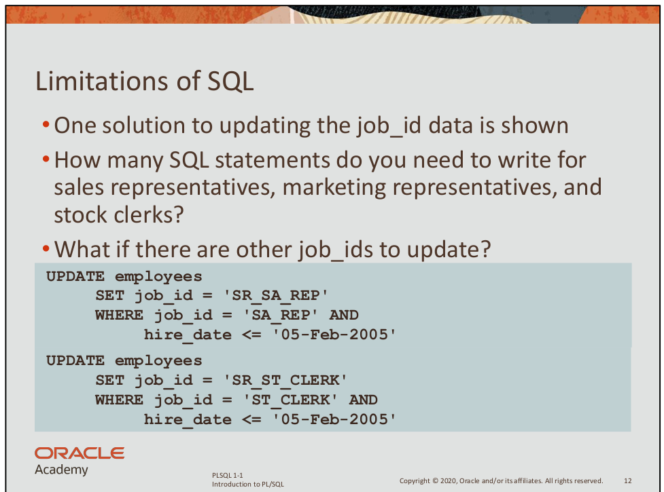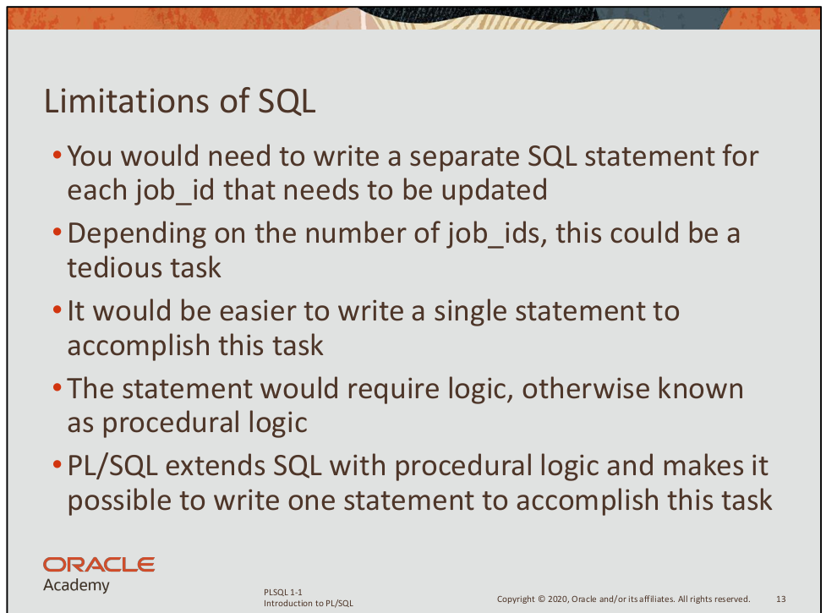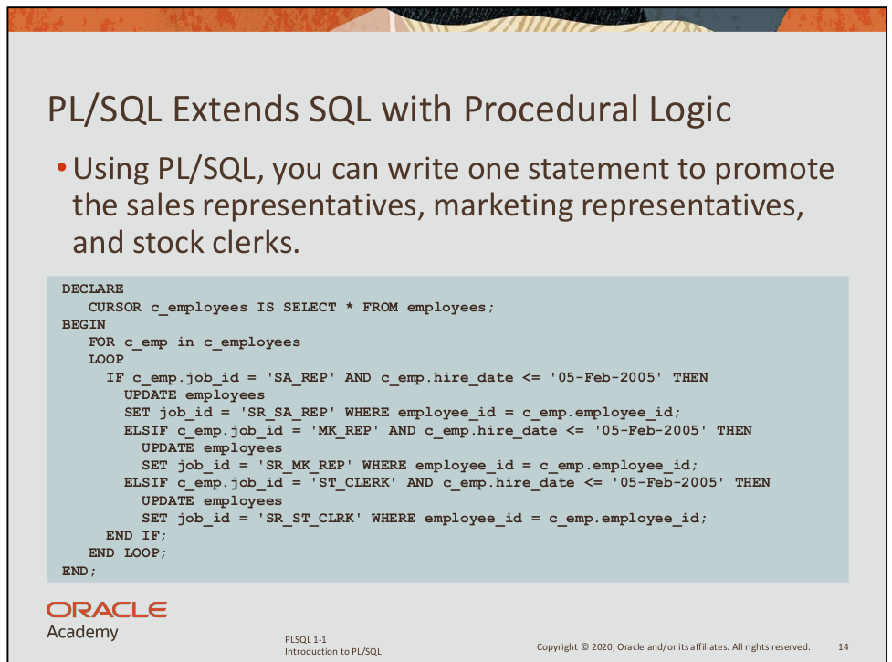3. List some examples of procedural constructs in PL/SQL.